Chariots of Fire – Study Guide

A Classic story
Chariots of Fire is a classic story. People overcoming barriers that are put in their way, overcoming conflicts to triumph in the end.
Not only is the story classic in this way, it is also classic in the way in which the plot is constructed.
Plot is a term which we can define as the events that make up a story, particularly as they relate to one another in a pattern, in a sequence, through cause and effect.
Let’s look at the key aspects of a plot of a story. We can divide these up into five key plot moments.
- Exposition
- Development of the action
- The turning point
- The climax
- The resolution
How do these relate to the story of Chariots of Fire?

Exposition
The opening of a film will set an “enigma”, a question that we hope will be explained as the story unfolds. It will also introduce all of the main characters in the story. It shows how they relate to one another, what their goals and motivations are, and the kind of person they are.
We also get to know the main characters, what drives them, what their aims are – the key elements which will drive the story forward. This phase ends, and the next begins, with the introduction of conflict.

Task
Think back to your viewing of Chariots of Fire.
- What is the enigma at the very beginning of the film?
- How are we introduced to the characters?
- How are the main characters of Abrahams and Liddell introduced to us?
- What are the initial conflicts that are introduced and at what point in the film do you think this happens?

Developing the action
The major characters have been introduced, their motives and aims have been made clear and they now begin to struggle against one another.
The main characters start to work towards their goal.
At this stage of the story we can indentify that a rivalry between Abrahams and Liddell starts to grow. But is this the only conflict which starts to develop. Think about how Abrahams is treated and viewed by his Cambridge college. How does Liddell deal with both his beliefs, his fame and his sister, Jennie?

The Turning point.
The turning point of the story is where the main characters make the single big decision that defines the outcome of their story and who they are as a person.
Where would you say that the turning point of Chariots of Fire is to be found?
Where is the moment that drives Abrahams and Liddell on towards their final glory?
Do you think that the film makers have set up one conflict but then replaced it with another?
And what are the moral conflicts that are set up in the film? How do they come to a turning point where both Abrahams and Liddell have to make decisions which will affect the outcome of the story?

The Climax
This is the moment of greatest tension in the story. The main characters have to prove themselves and overcome the final barriers in order to achieve their goals.
What are the final barriers for Liddell and Abrahams to overcome before they either succeed or fail in achieving their goals?
How is tension created regarding whether they will win their Olympic races or not?
How are these tensions related to other characters in the story?

Resolution
At the end of any story we will see the main character either win or lose in their efforts to reach their goal.
And in what other ways do they win or lose?
How does the tension created in the climax of the film resolve the aims of both Liddell and Abrahams?
How are both men’s stories rounded off?
Why do you think that the film ends on the memorial service and not at the 1924 Olympics in Paris?

Themes
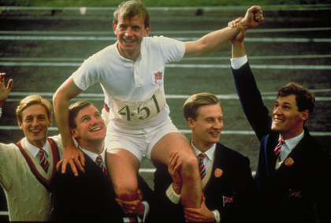You will already have studied the plot of Chariots of Fire – the step by step action in a story.
What we will now look at are the themes of the film. We could say that the themes of a story are the moral and the ideas behind the story; what the viewer or reader should take away as the main idea.
If you were asked to describe Chariots of Fire once you have seen it then you might describe the film by saying that it tells the story of two runners at the Olympic Games in Paris in 1924. This gives information about the plot of the film. However, you could describe it in a different way. You could say that the film is about “the will to win”, for example. This is one of the themes of the film.

Task
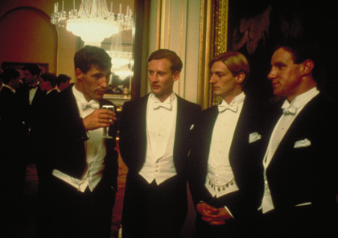What moments in the film illustrate this theme of “winning”? How important is the idea of “winning” in the development of the story?
Here are some other themes which are to be found in the story:
Prejudice, belief, hypocrisy, friendship, rivalry, patriotism.
Can you think of any other themes or ideas which the film illustrates?
Look at the Themes chart below. For each of the themes, try to remember moments in the film which might illustrate each theme and write these down in the column for each theme.

THEMES | EXAMPLE FROM FILM
RELIGIOUS BELIEF

CLASS

WINNING

The Idea of the Film
There are several elements to a marketing campaign for a film, from the trailer itself to posters in the street or on public transport, to online and viral marketing. The marketing campaign is designed to raise audience awareness and interest in a film in advance of, and during, its cinema release.
As well as using genre to gain our interest, marketing campaigns must also show us how a new film is different to others in the same genre: this is known as the USP (Unique Selling Point) of the film.
The USP is what separates one film title from another released at a similar time or within the same genre. The USP could be many things, for example:
- The innovative use of special effects
- An unusual mix of genres
- A popular star
A trailer will often be structured around the most appealing aspects of a film, disregarding the conventional narrative order. For example, you might see a funny moment taken from the ending of a comedy near the beginning of the trailer for that film, or a selection of clips chosen to attract the widest possible audience, such as a romantic clip in the trailer for an action film. Some trailers will aim to provide a basic narrative structure to guide us through the film’s storyline.

The Chariots of Fire trailer
Firstly, watch the trailer through twice before you answer these questions.
- What do you think is the USP of Chariots of Fire?
- What idea of the film does the trailer give? What is the film about?
- Why do you think the particular extracts from the film have been included in the trailer? What do they have in common?
- Why do you think that the trailer contains a number of quotations from newspaper reviews? What ideas do these quotations give us about the film?
- Why does one of the captions say “A Lap of Honour”?
- Another title calls the film The Classic British Film. How might this persuade people to go and see the film?
- What words are actually spoken in the trailer? What is said and how does this contribute to giving us an idea of the film?

